Shubham Rawat

MCA 2020 - 2021

**Java Assignment 3**

V) Programs based on Methods:

26. WAP to find factorial of a number using recursion.

import java.util.Scanner;

class factorial_reccur{

static int factorial(int n){

if(n==1)

return 1;

else

return(n*factorial(n-1));

}

public static void main(String args[]){

Scanner O = new Scanner(System.in);

System.out.print("\n Enter an No. : ");

int a = O.nextInt();

System.out.println(" Factorial of "+a+" is : "+factorial(a));

}

}

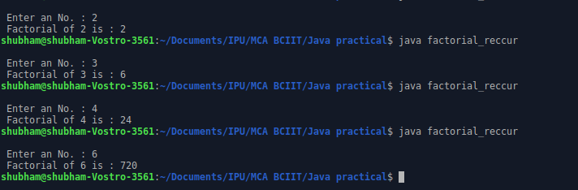

27. WAP to print the Fibonacci series using recursion.

import java.util.Scanner;

class fibonacii{

static int n1=0, n2=1, n3=0;

static void display(int n){

if(n>0){

n3 = n1 + n2;

n1 = n2;

n2 = n3;

System.out.print(" "+ n3);

display(n-1);

}

}

public static void main(String args[]){

Scanner O = new Scanner(System.in);

System.out.print("\n Enter a No. : ");

int a = O.nextInt();

System.out.print("\n "+n1+" "+n2);

display(a - 2);

}

}

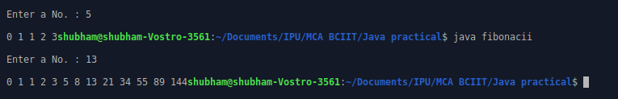

VI) Programs based on Method Overloading:

28. WAP to calculate area of rectangle, circle, square using method

Overloading.

import java.util.Scanner;

class Area_poly{

static void area(int side){

System.out.println(" Area of square side "+side+" is "+(side*side));

}

static void area(int length, int breadth){

System.out.println(" Area of rectangle of length : "+length+" and breadth : "+breadth+" is : "+(length*breadth));

}

static void area(float radius){

System.out.println(" Area of circle of radius : "+radius+" is : "+(radius*radius*3.14));

}

public static void main(String args[]){

Scanner O = new Scanner(System.in);

System.out.print("\n Choices \n 1. Area of Square \n 2. Area of rectangle \n 3. Area of Circle \n Enter your choice : ");

int a = O.nextInt();

int side,length,breadth;

float radius;

switch(a){

case 1:

System.out.print("\n Enter side of square : ");

side = O.nextInt();

area(side);

break;

case 2:

System.out.print("\n Enter length of rectangle : ");

length = O.nextInt();

System.out.print("\n Enter breadth of rectangle : ");

breadth = O.nextInt();

area(length,breadth);

break;

case 3:

System.out.print("\n Enter radius of cicle : ");

radius = O.nextFloat();

area(radius);

break;

default:

System.out.print("\n Invalid Input");

}

}

}

